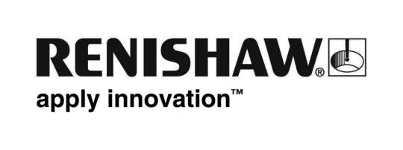
October 2018 Enquiries: Chris Pockett, Head of Communications (+44 1453 524133)

Exploring the potential of multi-laser AM at Formnext
To demonstrate the future of additive manufacturing (AM), Marc Saunders, Director of Global Solutions Centres at engineering technologies company Renishaw, is presenting at Formnext 2018, Messe Frankfurt, Germany. On Tuesday 13th November on the ‘TCT introducing’ stage from 11.30am, Saunders will explain how to radically improve productivity with multi-laser systems, without compromising on product quality.

The talk will complement the exhibition of Renishaw’s latest AM system, the RenAM 500Q, which includes four 500 W lasers to improve productivity in the most commonly used platform size. By speeding up the AM build process, manufacturers will see a reduction in cost-per-part, an increase in return on investment and a reduction in process waste, allowing AM to be used for applications that were previously uneconomical.

Saunders’ presentation will cover how developments in AM machines, such as the introduction of the RenAM 500Q, can boost build rates without compromising on part quality. In his talk, Saunders will address the interaction between lasers in a multi-laser system and how Renishaw has derived rules for laser assignment which enable high-integrity components to be built.

“Running up to four lasers in the space where there was previously one, can create challenges because of potential laser interactions,” explained Saunders. “Formnext is one of the world’s leading exhibitions for the AM industry, so it provides a great platform to demonstrate our expertise in overcoming the challenges of multi-laser technology. As the industry understands more about the benefits of multi-laser AM we will see a widespread increase in adoption.”

Saunders has over 25 years’ experience in high tech manufacturing and precision engineering sectors. He now manages Renishaw’s global network of Solutions Centres for metal AM, to offer customers hands-on experience with AM technology.

The Formnext exhibition is a leading manufacturing technologies event. At the show, the ‘TCT introducing’ stage will give attendees up-to-date information on the latest developments in 3D printing and additive manufacturing technology. Over the three-day conference, industry leaders will share their experience of AM and how it can make an impact on manufacturing.

For more information about how multiple lasers can work together on high-integrity parts, visit http://www.renishaw.com/productivity-without-compromise
Ends 363 words

Notes to editors
UK-based Renishaw is a world leading engineering technologies company, supplying products used for applications as diverse as jet engine and wind turbine manufacture, through to dentistry and brain surgery. It has over 4,500 employees located in the 36 countries where it has wholly owned subsidiary operations.

For the year ended June 2018 Renishaw recorded sales of £611.5 million of which 95% was due to exports. The company’s largest markets are China, the USA, Germany and Japan.

Throughout its history Renishaw has made a significant commitment to research and development, with historically between 13 and 18% of annual sales invested in R&D and engineering. The majority of this R&D and manufacturing of the company’s products is carried out in the UK.

The Company’s success has been recognised with numerous international awards, including eighteen Queen’s Awards recognising achievements in technology, export and innovation.

Further information at www.renishaw.com

