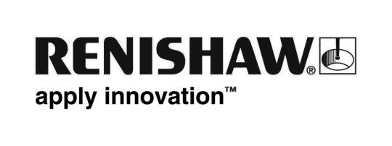
September 2017 Enquiries: Chris Pockett, Head of Communications (+44 1453 524133)

High hopes for Greenpower in Poland

Global engineering and scientific technologies company, Renishaw, is entering the second annual Greenpower event in Poznan, Poland. After racing to success at Rockingham in 2016, the UK based Renishaw team is set to compete in the Polish event on September 23rd and 24th, 2017. The event marks the first time that the Renishaw Greenpower team has competed internationally.

The Greenpower project aims to encourage young people aged nine to 25 to consider a career in engineering. As a part of the event, young people design, build and race fully functioning electric cars — a fun and inspiring project which helps young people to form a link between education and industry.

Greenpower was launched in the UK in 1999 and has since expanded to Spain, China, the USA and Poland. The inaugural Polish Greenpower race was held in September 2016 and the event returns for a second year to build on its success.

Renishaw’s Greenpower team has ranked extremely well in the UK, however the race in Poznan marks its first international event. The team is taking three of its electric cars, two of which have been extensively reworked since the 2016 season ended and one that is brand new. The UK team has already built a relationship with a local team from Silesian University, Gliwice, at previous races, with the University having visited Renishaw’s UK headquarters.

“The Poznan race gives us the opportunity to meet new people, learn from other teams and consider different approaches to designing the cars,” explained Tom Lawson, Technical Apprentice and Greenpower team member at Renishaw. “We’ve won numerous awards for our innovation and have been making incremental improvements to the cars since we first raced. It will be interesting to see what other teams bring to the race. Hopefully we can learn from them and benchmark for the upcoming season.”

“Poland boasts an extremely strong automotive industry, which is developing all the time,” explained Tomasz Rżysko, General Manager Renishaw Sp. z o.o. “This makes Poland an ideal location for Greenpower, as it helps to develop technical and engineering skills among young people to further the rapidly advancing industry. Poznan itself is home to automotive manufacturers such a Volkswagen and has a strong technical university, which makes it a natural fit for the race itself.”

Renishaw Sp. z o.o was formed in 2002 and its new office in Warsaw was opened in 2014. The subsidiary’s 25 employees offers sales and technical support for Renishaw’s full product portfolio including additive manufacturing, Raman spectroscopy, metrology and encoders.

For more information on Renishaw visit http://www.renishaw.com/.

Ends 425 words
Notes to editors
UK-based Renishaw is a world leading engineering technologies company, supplying products used for applications as diverse as jet engine and wind turbine manufacture, through to dentistry and brain surgery. It has over 4,000 employees located in the 35 countries where it has wholly owned subsidiary operations.

For the year ended June 2017 Renishaw recorded sales of £536.8 million of which 95% was due to exports. The company’s largest markets are China, the USA, Japan and Germany.

Throughout its history Renishaw has made a significant commitment to research and development, with historically between 14 and 18% of annual sales invested in R&D and engineering. The majority of this R&D and manufacturing of the company’s products is carried out in the UK.

The Company’s success has been recognised with numerous international awards, including eighteen Queen’s Awards recognising achievements in technology, export and innovation.

Further information at www.renishaw.com

