February 2020 – for immediate release

Introducing Renishaw Correlate™

Renishaw introduces its new Correlate™ software module, to combine imaging techniques and maximise the effectiveness of microscopic methods.

Modern laboratories host a variety of different microscope systems which are usually used in isolation. Although they are often viewed separately, many of the techniques are complementary and can be used together to get a better interpretation of your sample. By overlaying images from multiple techniques, a deeper understanding and easier interpretation of multiple microscopy methods is possible.

Renishaw’s Correlate software module is ideal for analytical scientists who want to combine Raman spectroscopic images with other imaging techniques. It enables the comparison of Raman results with other commonly used microscopes including SEM, fluorescence, AFM, Infra-Red and optical microscopes.

The Correlate module is available as part of the WiRE 5.3 software and can be used with the inVia™ confocal Raman microscope, the Virsa™ Raman Analyser and Renishaw RA800 series. For further information, visit www.renishaw.com/correlate

-ENDS-

Notes to editors

UK-based Renishaw is a world leading engineering technologies company, supplying products used for applications as diverse as jet engine and wind turbine manufacture, through to dentistry and brain surgery. It has over 4,500 employees located in the 36 countries where it has wholly owned subsidiary operations.

For the year ended June 2019 Renishaw recorded sales of £574 million of which 94% was due to exports. The company’s largest markets are the USA, China, Japan and Germany.

Throughout its history Renishaw has made a significant commitment to research and development, with historically between 13 and 18% of annual sales invested in R&D and engineering. The majority of this R&D and manufacturing of the company’s products is carried out in the UK.

The Company’s success has been recognised with numerous international awards, including eighteen Queen’s Awards recognising achievements in technology, export and innovation.

Further information at www.renishaw.com

For further information

Please contact:
David Reece
Renishaw plc
New Mills
Wotton-under-Edge
Gloucestershire GL12 8JR UK
Tel: +44 1453 523968 (direct)
Tel: +44 1453 524524 (switchboard)
Fax: +44 1453 523901
Email: david.reece@renishaw.com
www.renishaw.com/raman

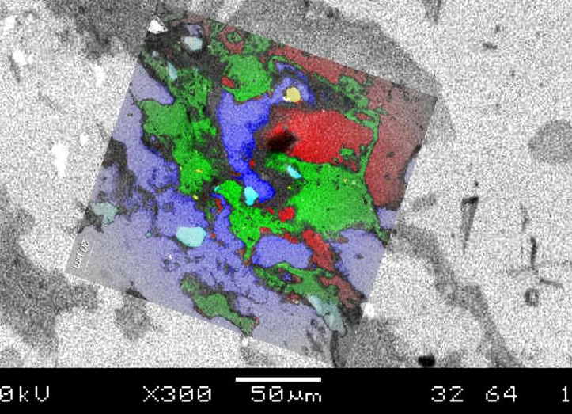
High-resolution SEM backscattered electron image with overlaid Raman image

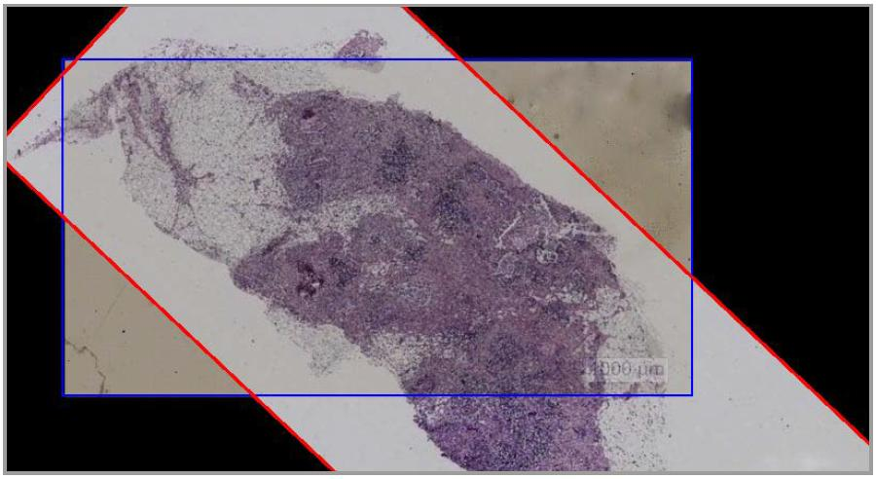
Oesophageal tissue sections. Two adjacent microtome slices, nominally identical - H&E stained (red), Unstained, Raman imaged (blue). Combined image enables regions of interest to be defined on unstained tissue section

