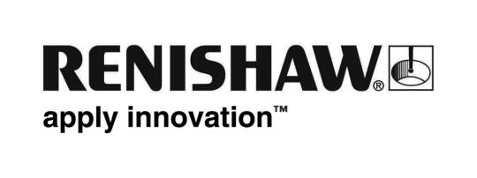
November 2018 Enquiries: Chris Pockett, Head of Communications (+44 1453 524133)

Manufacturing success earns Renishaw prestigious award
At The Manufacturer MX Awards, global engineering company Renishaw won the coveted Manufacturing in Action accolade. The award was given to Renishaw after Jonny Williamson, editor of TheManufacturer.com experienced first-hand the innovative technology installed at Renishaw’s South Wales facility in Miskin, near Cardiff.

The Manufacturer MX Awards are delivered by The Manufacturer and the Institution of Mechanical Engineers (IMechE) to benchmark performance across its eleven manufacturing categories. On November 15th as part of Digital Manufacturing Week, the awards were presented at the Exhibition Centre Liverpool.

The Manufacturing in Action Award is given to a company that a member of The Manufacturer’s editorial team has personally visited in the past twelve months. The companies shortlisted for the award are those who are felt to exemplify the best characteristics of future-facing, progressive businesses. Renishaw was shortlisted alongside Accolade Wines, British Rototherm, Lintott Control Systems Limited, MBDA and PP Control and Automation.

Renishaw’s award win follows Jonny Williamson’s tour of its Miskin facility earlier this year, including its production halls for machining and assembly, low-volume production line and the Healthcare Centre of Excellence. Also at the Miskin site is the Fabrication Development Centre, a dedicated education facility, which local schools can use as part of their science, technology, engineering and maths (STEM) lessons.

“Since acquiring the Miskin facility in 2011 we have built a strong team who have successfully applied the manufacturing strategies in use at our other UK sites, with strong support from staff at those sites, especially during the early years.” explained Gareth Hankins, Director – Group Manufacturing Services of Renishaw. “To win this prestigious award is a real compliment to the wider team in Renishaw’s manufacturing services operation, particularly when we consider the achievements of the other excellent shortlisted companies.”

“Renishaw represents innovation and technological advancement at every level and winning The Manufacturer MX Award for Manufacturing in Action showcases Renishaw as a forward-thinking engineering business that has truly invested in the future,” explained Jonny Williamson, Editor of TheManufacturer.com. “Of everything I saw during my tour of Miskin, I was particularly taken with Renishaw’s machining hall. The company has developed an impressive, highly sophisticated system which works to an incredible degree of accuracy by leveraging the very best of the physical and digital world.”

Renishaw celebrated its 45th birthday in 2018 and in that time has grown into an industry-leading organisation that employs over 5,000 people in 36 countries. For the year ended June 2018, Renishaw recorded sales of £611.5 million of which 95% was due to exports. The business started by manufacturing precision metrology probes and has developed into new and exciting markets such as medical robots and metal 3D printing.

For more information, visit www.renishaw.com.

Ends 442 words
Notes to editors
UK-based Renishaw is a world leading engineering technologies company, supplying products used for applications as diverse as jet engine and wind turbine manufacture, through to dentistry and brain surgery. It has over 4,500 employees located in the 36 countries where it has wholly owned subsidiary operations.

For the year ended June 2018 Renishaw recorded sales of £611.5 million of which 95% was due to exports. The company’s largest markets are China, the USA, Germany and Japan.

Throughout its history Renishaw has made a significant commitment to research and development, with historically between 13 and 18% of annual sales invested in R&D and engineering. The majority of this R&D and manufacturing of the company’s products is carried out in the UK.

The Company’s success has been recognised with numerous international awards, including eighteen Queen’s Awards recognising achievements in technology, export and innovation.

Further information at http://www.renishaw.com/

