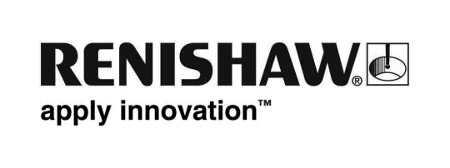
November 2019 Enquiries: Chris Pockett, Head of Communications (+44 1453 524133)

National award recognises Renishaw employee’s commitment to STEM outreach
In November 2019, at the STEM Inspiration Awards, Stephen Pickles, Process Development Technician at global engineering technologies company Renishaw, won the Inspirational Science, Technology, Engineering and Maths (STEM) Technician Award. Pickles, who works at the company’s Miskin site in South Wales, was praised for his dedication to STEM education outreach.

Pickles has volunteered as a STEM ambassador for four years, where he shares his knowledge and passion for engineering with local school students in South Wales. As well as visiting schools, he also uses his time outside of work to deliver STEM outreach to scout groups.

One major project he has been involved in this year is with Howell’s School, Cardiff, working with students on their Engineering Education Scheme Wales (EESW) Sixth Form Projects. This included designing a smart parts bin, to alert the operator if there are enough parts on the line for a product to be manufactured.

“I was inspired to become an engineer because of a STEM engagement programme,” explained Pickles. “I’ve dedicated myself to bringing this same benefit to other people. Engineering is a brilliant career path that means you can be hands on, practical and creative.”

“This year, Stephen has made an enormous contribution to young people in South Wales,” commented Simon Biggs, Education Outreach Officer at Renishaw. “He has gone from strength-to-strength and has invested a huge amount of his time to inspire young people to join the profession. Stephen is a fantastic role model, both as a talented engineer and as an ambassador to young people.”

Pickles joined Renishaw as a mechanical manufacturing apprentice and has excelled at his HNC, NVQ level 3 and his project work at Renishaw. During his second year as an apprentice, he won Welsh Apprentice of the Year in 2017. He was also a runner up in last year’s STEM Inspiration Awards in the same category. As a winner this year, he is invited to visit CERN in Switzerland, to see cutting edge science in action and meet leading scientists, technicians and engineers at the facility.

Renishaw has over 150 STEM ambassadors as well as a dedicated education outreach facility at its Miskin site, which schools in South Wales are able to access for free. For more information or to book a workshop, visit
https://www.renishaw.com/en/education-outreach--34713.

Ends 378 words
Notes to editors
UK-based Renishaw is a world leading engineering technologies company, supplying products used for applications as diverse as jet engine and wind turbine manufacture, through to dentistry and brain surgery. It has over 5,000 employees located in the 36 countries where it has wholly owned subsidiary operations.

For the year ended June 2019 Renishaw recorded sales of £573.96 million of which 95% was due to exports. The company’s largest markets are China, the USA, Germany and Japan.

Throughout its history Renishaw has made a significant commitment to research and development, with historically between 13 and 18% of annual sales invested in R&D and engineering. The majority of this R&D and manufacturing of the company’s products is carried out in the UK.

The Company’s success has been recognised with numerous international awards, including eighteen Queen’s Awards recognising achievements in technology, export and innovation.

Further information at www.renishaw.com

