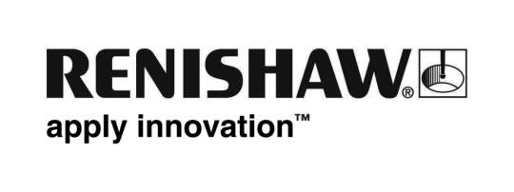
July 2018 Enquiries: Chris Pockett, Head of Communications (+44 1453 524133)

National award shortlist for Wotton Travel’s youngest employee
Rachel Ball, Leisure Travel Consultant at Wotton Travel, a wholly owned Renishaw company, has been shortlisted for the Travel Trade Gazette’s TTG Travel Awards Young Travel Agent of the Year accolade. The final will be held at the Lyceum Theatre in London, UK on September 17th, with an after party at the Savoy Hotel.

Ball first came to Wotton Travel in May 2013 for two week’s work experience as part of her travel and tourism BTEC at Gloucester College. She then went on to gain hotel reservations experience to provide a foundation for her career in travel.

Ball joined Wotton Travel in 2015 as a Trainee Consultant, becoming a Junior Consultant two years later. In her time at Wotton Travel, Ball has visited Dubai, Cape Verde and America and completed numerous courses to further her knowledge and understanding. She has also been involved in launching an offers board for employees at Renishaw, attended careers evenings at local schools, attended supplier evenings and helped set up a service for special occasions.

“When I came to Wotton Travel for work experience, I instantly realised it was the place for me,” explained Rachel Ball, Leisure Travel Consultant at Wotton Travel. “It’s great to be recognised for doing something I love ─ I couldn’t ask for a better job in a better company.”

“Rachel’s love of the industry shines through everything she does,” explained Wendy Walker, Director at Wotton Travel. “We realised early on that she has the drive, passion and interest to be successful as a travel agent. As soon as we had a vacancy, we got in touch – she even turned down an offer from a major travel provider to work here. It is a privilege to work with Rachel as she is a wonderful colleague and a great ambassador for the industry.

“This is the first time we have entered the TTG Awards and it is great to be recognised on the shortlist,” added Walker. “Wotton Travel is a small business in comparison to many other entrants, but our passionate and experienced team works hard to make each holiday a perfect fit for every customer.”

Global engineering company Renishaw founded Wotton Travel in 1986 to focus on business travel for Renishaw. The agency now provides high quality travel across the globe to business and leisure customers. Wotton Travel’s dedicated staff have over 295 years’ experience in the travel industry, which they use to provide tailored advice and recommendations for clients.

Regarded as the toughest in the business to win, the TTG Travel Awards celebrate the best in the UK travel industry. For more information on Wotton Travel’s business and leisure offerings, visit www.wtlholidays.com.

Ends 444 words
Notes to editors
UK-based Renishaw is a world leading engineering technologies company, supplying products used for applications as diverse as jet engine and wind turbine manufacture, through to dentistry and brain surgery. It has over 4,500 employees located in the 35 countries where it has wholly owned subsidiary operations.

For the year ended June 2018 Renishaw recorded sales of £611.5 million of which 95% was due to exports. The company’s largest markets are China, the USA, Germany and Japan.

Throughout its history Renishaw has made a significant commitment to research and development, with historically between 13 and 18% of annual sales invested in R&D and engineering. The majority of this R&D and manufacturing of the company’s products is carried out in the UK.

The Company’s success has been recognised with numerous international awards, including eighteen Queen’s Awards recognising achievements in technology, export and innovation.

Further information at www.renishaw.com

