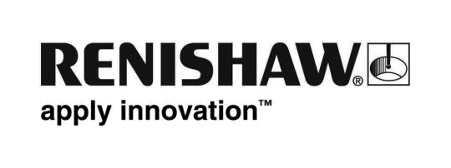
July 2019 Enquiries: Chris Pockett, Head of Communications (+44 1453 524133)

Renishaw and Cardiff Blues raise the aspirations of young people
Global engineering technologies company, Renishaw, and Cardiff Blues Community Foundation have delivered a successful eight-week pilot programme as part of a three-year partnership to raise the aspirations of local year 8 and 9 students. After the Raising Aspirations programme, where students participated in workshops and visited Renishaw’s Miskin facility in South Wales, attendees had greatly increased perception of their abilities in categories such as teamwork, communication and goal setting.

Since Renishaw began working with Cardiff Blues Rugby Club in January 2019, the programme has already worked with 102 pupils across five different schools in the Cardiff region. The first phase lasted eight weeks and involved running workshops on team building, goal setting, communication, leadership, career pathways and interview preparation.

Students were also given the opportunity to visit Renishaw’s site in Miskin where they took part in a 3D printing workshop and an apprenticeship talk led by the company’s education outreach team. At the end of the programme, pupils were invited to a celebration event at Cardiff Arms park Stadium where they watched a game between Cardiff Blues and Scarlets and met some of the players.

“It’s only been running eight-weeks, but we’ve already seen positive results,” explained Nadine Griffiths, Community Foundation Director at Cardiff Blues. “We’ve had great feedback from the students involved. In the first week, attendees rated their skill sets out of six ― the average was two. By the last week, there was a big improvement with many rating their skills at five or six.”

“This goes to show how far a short programme can go at changing the minds of young people about their capabilities and their future,” added Griffiths. “Eight weeks is only a start and it will never be a quick fix, but we want to leave a legacy so that these children can help mentor the new intake of children that we will work with. Renishaw’s support has been essential to the delivery of the programme as it enabled us to hire a full-time officer to actively engage with these young people.”

“It is fantastic to see such positive feedback from participants in the Raising Aspirations programme,” explained Chris Pockett, Head of Communications at Renishaw. “Renishaw contributes to and runs numerous education outreach projects that encourage young people to consider a career in engineering. It is common that young people are unsure about what careers are open to them and what routes they can take. By visiting schools and supporting projects like this, Renishaw hopes to encourage young people to aim high.”

Renishaw is committed to bringing clear and positive messages about science and engineering into schools and colleges throughout the Gloucestershire, Bristol and South Wales regions using its education outreach programme. To find out more about the educational opportunities at Renishaw for local schools visit www.renishaw.com/educationoutreach.

Ends 464 words
Notes to editors
UK-based Renishaw is a world leading engineering technologies company, supplying products used for applications as diverse as jet engine and wind turbine manufacture, through to dentistry and brain surgery. It has 5,000 employees located in the 36 countries where it has wholly owned subsidiary operations.

For the year ended June 2019 Renishaw recorded sales of £574 million of which 94% was due to exports. The company’s largest markets are the USA, China, Japan and Germany.

Throughout its history Renishaw has made a significant commitment to research and development, with historically between 13 and 18% of annual sales invested in R&D and engineering. The majority of this R&D and manufacturing of the company’s products is carried out in the UK.

The Company’s success has been recognised with numerous international awards, including eighteen Queen’s Awards recognising achievements in technology, export and innovation.

Further information at www.renishaw.com

