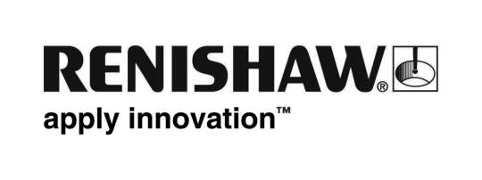
13 February 2017 Enquiries: Chris Pockett, Head of Communications (+44 1453 524133)

Renishaw announces Super Science £10K Giveaway winner

Global engineering company Renishaw has awarded £10,000 to Southville Primary School, Bristol, winner of its Super Science competition held in collaboration with the Bristol Post newspaper. The school will use the prize money to purchase a range of indoor and outdoor science equipment including circuits, magnets, microscopes and weather stations.

Southville Primary School was the winner of a random draw, which took place on December 16, 2016. Schools could increase their chances of winning by collecting as many Super Science tokens as possible and exchanging them for draw tickets.

"There are so many ways in which science and engineering companies can support schools and nurture pupils’ interest in STEM subjects," explained Chris Pockett, Head of Communications at Renishaw. "Research by King's College London shows that children develop an interest in science very early on, before the age of 14. To encourage this interest, schools need resources and expertise they might not always have. This is where engineering and science companies can truly make a difference. The Super Science £10K Giveaway will help advance Southville Primary School’s teaching in science and technology.

Chris Pockett and Julie Collins, Education Liaison Manager at Renishaw presented Southville Primary School with a cheque for £10,000 during a school assembly on February 7, 2017.

“Southville Primary School is extremely grateful to Renishaw for the Super Science funding," commented Sandie Smith, Headteacher at Southville Primary School. "Apart from basic resources to enhance learning in Science, Maths, Healthy Schools and Eco agendas, we will be installing weather stations, adding to our raised bed planting areas and every class will have stick insects to learn about life cycles."

As a strong advocate of workplace training and development, Renishaw currently employs over 100 manufacturing, engineering and software apprentices. By getting involved in initiatives such as the Super Science competition, Renishaw is investing in the engineers of the future.

Ends 305 words
Notes to editors
UK-based Renishaw is a world leading engineering technologies company, supplying products used for applications as diverse as jet engine and wind turbine manufacture, through to dentistry and brain surgery. It has over 4,000 employees located in the 35 countries where it has wholly owned subsidiary operations.

For the year ended June 2016 Renishaw recorded sales of £436.6 million of which 95% was due to exports. The company’s largest markets are China, the USA, Japan and Germany.

Throughout its history Renishaw has made a significant commitment to research and development, with historically between 14 and 18% of annual sales invested in R&D and engineering. The majority of this R&D and manufacturing of the company’s products is carried out in the UK.

The Company’s success has been recognised with numerous international awards, including eighteen Queen’s Awards recognising achievements in technology, export and innovation.

Renishaw is listed on the London Stock Exchange (LSE:RSW) where it is a constituent of the FTSE 250, with a current valuation of around £1.8 billion.

Further information at www.renishaw.com

