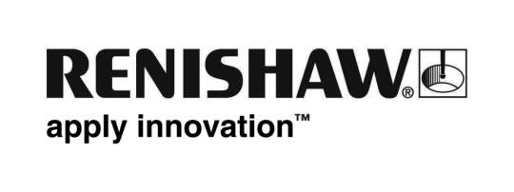
January 2011 – for immediate release

Renishaw appoints dental technology specialist for its Nordic operation

The Nordic office of Renishaw plc, global specialists in industrial metrology and precision healthcare solutions, has announced the appointment of Martin Wadman as a System Support Engineer for its rapidly expanding dental business. Wadman has more than 15 years experience in the dental industry with Nobel Biocare, and in his new role at Renishaw AB, in Järfälla, near Stockholm, Sweden, he will be responsible for helping to support the company’s growing base of dental CAD/CAM products.

Speaking about the new appointment, Bo Eneholm, General Manager of Renishaw AB, says, “We are delighted to welcome Martin to Renishaw at an exciting time in the development of our dental business. His specialist experience will help us to ensure that customers for our innovative Renishaw CAD/CAM milling and scanning products, distributed by our global partner Biomet 3i, will be strongly supported in delivering the highest quality restorations to dentists and their patients.”

Wadman brings with him a wealth of engineering and dental market experience, ranging from his role as an officer within the Swedish Royal Anti-Aircraft Regiment working on air defence missile systems, to his 15 years at dental company Nobel Biocare AB, based in Gothenburg. At the latter company he held various roles supporting their NobelProcera™ business, including field installation, maintenance and repair, customer training, and most recently as a Systems Specialist within the Global Product and Marketing Department, where he was responsible for developing and documenting new products and solutions.

Says Wadman, “I am very pleased to join Renishaw, which is already the world’s leading provider of scanning systems for dental laboratories, and which clearly has ambitions to further strengthen its presence in the wider dental CAD/CAM market. Renishaw is a highly respected engineering and healthcare company and I look forward to making a full contribution to its development in the Nordic region.”
Note: Nobel Biocare and NobelProcera are trade marks of the Nobel Biocare group
Ends

