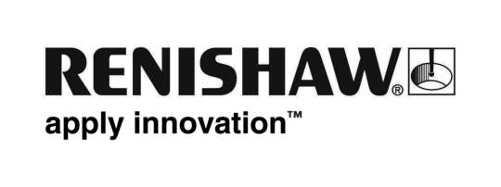
May 2019 Enquiries: Chris Pockett, Head of Communications (+44 1453 524133)

Renishaw celebrated for successful UK-India relations
At the third annual Indian Awards, global engineering company, Renishaw, won the Larger Business Award. Presented at the UK’s Houses of Parliament on May 29, 2019, the accolade celebrates Renishaw’s successful operations in India, as well as the company’s work with the High Commission of India.

Renishaw has offices in five Indian cities, as well as sales engineers in other regions. In Pune, Renishaw operates from an 80,000 square foot building, which includes a manufacturing facility, customer demonstration and training facilities, a procurement operation and an Additive Manufacturing Solutions Centre.

Alongside this, Renishaw is involved in several programmes and initiatives to improve UK and India relations. Rhydian Pountney, Director of Group Commercial Services and an experienced export professional, has been the UK chair of the UK-India Joint Economic and Trade Committee (JETCO) Working Group since 2013. Pountney has also been involved in the Make in India initiative and works as a mentor as part of the Access India Programme (AIP), organised by the High Commission of India in London, to help smaller businesses to establish Indian manufacturing operations.

“Renishaw’s operations in India started as just a small office,” explained Pountney. “30 years later, we now employ over 430 people, across five offices, including our biggest manufacturing site outside the UK. As the industrial economy in India continues to grow, Renishaw is at the forefront, working with customers and partners to provide cutting-edge manufacturing solutions. We also work with smaller UK companies, to help them realise success overseas.

“This is the first time Renishaw has won a UK award specifically for its work in India,” added Pountney. “This award recognises the work of Renishaw’s employees, both in the UK and in India, and commemorates the company’s investment in facilities, people and expertise. Renishaw will continue to invest in India and to strengthen the relationship at a time when Indian relations are increasingly important to Renishaw and the UK as a whole.”

The Indian Awards recognise an elite handful of organisations, individuals and businesses responsible for strengthening UK-India relations. Renishaw is well established in India, having opened a representative office in 1993, which became a wholly owned subsidiary in 2000. For more information on Renishaw, visit www.renishaw.com/news.

Ends 364 words
Notes to editors
UK-based Renishaw is a world leading engineering technologies company, supplying products used for applications as diverse as jet engine and wind turbine manufacture, through to dentistry and brain surgery. It has over 4,500 employees located in the 36 countries where it has wholly owned subsidiary operations.

For the year ended June 2018 Renishaw recorded sales of £611.5 million of which 95% was due to exports. The company’s largest markets are China, the USA, Germany and Japan.

Throughout its history Renishaw has made a significant commitment to research and development, with historically between 13 and 18% of annual sales invested in R&D and engineering. The majority of this R&D and manufacturing of the company’s products is carried out in the UK.

The Company’s success has been recognised with numerous international awards, including eighteen Queen’s Awards recognising achievements in technology, export and innovation.

Further information at http://www.renishaw.com/

