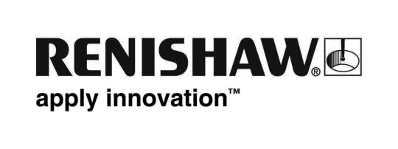
November 2017 Enquiries: Chris Pockett, Head of Communications (+44 1453 524133)

Renishaw celebrates educational programme’s success

Gloucestershire based engineering and scientific technologies company, Renishaw, has celebrated the success of twelve graduates of the SS Great Britain Trust’s flagship educational programme, Future Brunels. The scheme encourages young people to engage in science, technology, engineering and maths (STEM) projects and visit leading engineering firms, motivating them to pursue a STEM career. The third group of students to finish the programme graduated on September 28th, 2017.

The five-year rolling programme involves twelve individuals each year from schools across Bristol, selected for their potential in STEM subjects. The students visit the Brunel Institute, which houses one of the world’s finest maritime collections, as well as local science and engineering businesses.

Renishaw is involved as a member of the Brunel Institute Corporate Academy (BICA). Each year, Renishaw hosts a hands-on workshop for the Year 10 Future Brunels, introducing them to the applications of precision metrology in engineering.

“The Future Brunels programme aims to provide the students with a rich variety of experiences and STEM role models, so that they unlock their potential and recognise different career possibilities,” explained Rachel Roberts, Head of Education and Communities for the SS Great Britain Trust. “The first cohort to graduate have now completed their A-Levels and are embarking on a range of STEM-related careers and study including studying natural sciences, computer science, chemistry, medicine and an aircraft technician apprenticeship.

“Having support from local companies is crucial to the success of the programme,” continued Roberts. “By hosting visits, Renishaw has been able to inspire the young people we work with, advise them on routes into engineering and help to develop their knowledge and confidence.”

“Congratulations to the most recent graduates,” said Chris Pockett, Head of Communications at Renishaw. “We hope the skills and experiences that they have gained throughout the programme will benefit them in their careers or further study.”

Renishaw runs a popular education outreach programme, working with schools across Gloucestershire, Bristol and South Wales. The company also supports a number of activities to inspire young people into engineering, including work with Greenpower, Bristol Music Trust, Engineering Education Scheme Wales and Aerospace Bristol.

For more information on Renishaw’s education outreach programme, visit http://www.renishaw.com/en/education-outreach--34713.

Ends 359 words
Notes to editors
UK-based Renishaw is a world leading engineering technologies company, supplying products used for applications as diverse as jet engine and wind turbine manufacture, through to dentistry and brain surgery. It has over 4,000 employees located in the 35 countries where it has wholly owned subsidiary operations.

For the year ended June 2017 Renishaw recorded sales of £536.8 million of which 95% was due to exports. The company’s largest markets are China, the USA, Japan and Germany.

Throughout its history Renishaw has made a significant commitment to research and development, with historically between 14 and 18% of annual sales invested in R&D and engineering. The majority of this R&D and manufacturing of the company’s products is carried out in the UK.

The Company’s success has been recognised with numerous international awards, including eighteen Queen’s Awards recognising achievements in technology, export and innovation.

Further information at www.renishaw.com

