
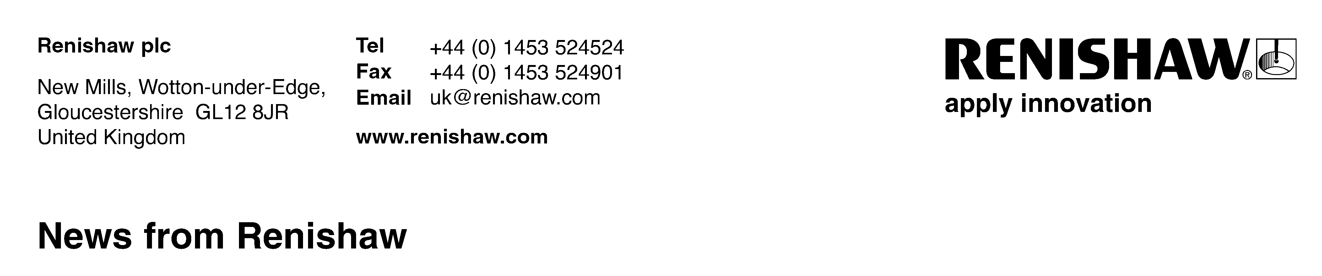
September 2018 Enquiries: Chris Pockett, Head of Communications (+44 1453 524133)

Renishaw explores innovations in AM at TCT Show
Marc Saunders, Director of Global Solutions Centres at engineering technologies company Renishaw, is presenting at TCT Show 2018 at NEC, Birmingham, UK. On Tuesday 25th September, at 11.50am on the TCT Introducing Stage (H50), Saunders will give expert insight into how multi-laser additive manufacturing (AM) can boost productivity and reduce cost-per-part.

The talk will reinforce Renishaw’s presence at TCT Show, where experts will be on hand from 25th to 27th September on stand N36. On the stand, the company will exhibit parts spanning several different industries including aerospace, automotive, medical and dental.

Additive manufacturing is moving from a prototyping technology to a serialised industrial production technique. For companies to adopt AM for production, it must be efficient, cost-effective and offer good performance. Saunders’ presentation will cover Renishaw’s expertise in driving AM forward, discussing the company’s RenAM 500Q and how the system will broaden the appeal of AM into applications that were previously uneconomic.

“For AM adoption to become widespread, industry must be aware of how the technology is developing and the efficiency and accessibility benefits that come with it,” explained Saunders. “TCT Show is a leading event for the 3D printing and AM industry and it provides a powerful platform to transfer knowledge to the rest of the sector.”

“Multi-laser technology will revolutionise the industry,” added Saunders. “This is because of the benefits it can offer in terms of reduced cost-per-part and increased productivity. Other features, such as automated powder handling are also introducing additional benefits that can increase return on investment, reduce operator touch time and reduce process waste.”

Saunders has over 25 years' experience in high-tech manufacturing and precision engineering, specifically in the aerospace sector. He also played a key role in developing Renishaw’s award-winning RAMTIC automated machining platform, a modified machine tool used to produce Renishaw products.

Saunders now manages a global network of Solutions Centres for metal AM, to provide customers with hands-on experience with AM technology. They can then see the potential of AM for their own innovative products.

For more information on Renishaw’s additive manufacturing products and services visit www.renishaw.com/additive.

Ends 354 words
Notes to editors
UK-based Renishaw is a world leading engineering technologies company, supplying products used for applications as diverse as jet engine and wind turbine manufacture, through to dentistry and brain surgery. It has over 4,500 employees located in the 36 countries where it has wholly owned subsidiary operations.

For the year ended June 2018 Renishaw recorded sales of £611.5 million of which 95% was due to exports. The company’s largest markets are China, the USA, Germany and Japan.

Throughout its history Renishaw has made a significant commitment to research and development, with historically between 13 and 18% of annual sales invested in R&D and engineering. The majority of this R&D and manufacturing of the company’s products is carried out in the UK.

The Company’s success has been recognised with numerous international awards, including eighteen Queen’s Awards recognising achievements in technology, export and innovation.

Further information at www.renishaw.com

