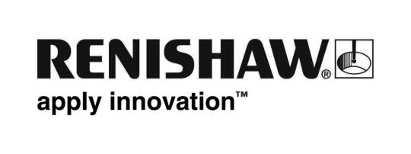

May 2017 Enquiries: Chris Pockett, Head of Communications (+44 1453 524133)

Renishaw hosts 150 local pupils for Bloodhound SSC education day

Global engineering technologies company, Renishaw, hosted over 150 students from local primary schools for an education day on the Bloodhound SSC, a supersonic car that aims to break the 1000 mph land speed record. The students visited Renishaw’s Gloucestershire headquarters to see a full-scale model of the supersonic car and participate in hands-on activities. The students were able to see the application of engineering in an innovative project and how it links to the school curriculum.

The Bloodhound SSC is a supersonic vehicle that aims to break the land speed record. Renishaw has contributed its additive manufacturing expertise to produce prototype parts for the car, including a titanium nose tip and steering wheel. The project is also a platform for education outreach, where a dedicated team works to inspire young people into future science, technology, engineering and maths (STEM) careers.

On the day, the education team from Bloodhound SSC delivered a presentation explaining the story of the project, focussing on how the car has been designed and built, who will be racing it and the parts that Renishaw has produced. The students put this into context by viewing a full-size model of the Bloodhound SSC car in the Renishaw Innovation Centre. The pupils also participated in a hands-on workshop to make a balloon racing car, using balloons, paper, tape and wheels, which they raced on their return to the schools.

“The Bloodhound SSC is an incredibly exciting and engaging project,” explained Simon Biggs, Education Liaison Officer at Renishaw. “It is important to open young people’s eyes to innovative projects to increase enthusiasm towards STEM subjects and draw a link back to the school curriculum.”

Students attended from six local primary schools; North Nibley Church of England Aided School, Kingswood Primary School, Tortworth Primary School, Charfield Primary School, plus two schools from Wotton-under-Edge - The British School and Blue Coat Church of England Primary School. The day was split into three sessions, with two schools attending each session and transportation supplied by Renishaw.

Renishaw is involved in a number of local and national education outreach projects to encourage young people to engage with STEM activities including work with; Greenpower, Young Engineers, Bristol Music Trust, ss Great Britain Trust, and also runs Engineering and Software work experience weeks.

For more information on Renishaw’s involvement in the Bloodhound SSC project and its commitment to education outreach visit www.renishaw.com

Ends 385 words
Notes to editors
UK-based Renishaw is a world leading engineering technologies company, supplying products used for applications as diverse as jet engine and wind turbine manufacture, through to dentistry and brain surgery. It has over 4,000 employees located in the 35 countries where it has wholly owned subsidiary operations.

For the year ended June 2016 Renishaw recorded sales of £436.6 million of which 95% was due to exports. The company’s largest markets are China, the USA, Japan and Germany.

Throughout its history Renishaw has made a significant commitment to research and development, with historically between 14 and 18% of annual sales invested in R&D and engineering. The majority of this R&D and manufacturing of the company’s products is carried out in the UK.

The Company’s success has been recognised with numerous international awards, including eighteen Queen’s Awards recognising achievements in technology, export and innovation.

Renishaw is listed on the London Stock Exchange (LSE:RSW) where it is a constituent of the FTSE 250, with a current valuation of around £1.8 billion.

Further information at www.renishaw.com

