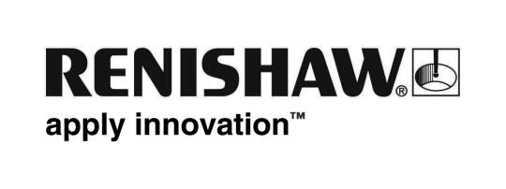
February 2019 Enquiries: Chris Pockett, Head of Communications (+44 1453 524133)

Renishaw hosts robotics challenge to find engineers of tomorrow
To inspire students to consider a career in engineering, global engineering technologies company Renishaw hosted a regional heat of the Tomorrow’s Engineers EEP Robotics Challenge at its Gloucestershire, UK, headquarters. The challenge, run by EngineeringUK, immerses young people in real-world engineering, technology and computing challenges and gives them the opportunity to demonstrate their skills at engineering facilities around the country.

The Tomorrow’s Engineers EEP Robotics Challenge is a curriculum-linked, year-long programme for students aged eleven to 14. Every school in the UK is invited to join and participating schools are sent a LEGO® MINDSTORMS® Education EV3 set along with the necessary training and resource materials. Student teams use the kit to build, program and control robots to complete a series of short missions at regional heats, with the aim to reach the final at The National Big Bang Fair.

During the regional heat at Renishaw, students built their robot to complete a test of speed and agility as well as completing humanitarian aid challenges. They then completed a teamwork challenge organised by Renishaw, where they created an RGB torch production line to build ten or more high-quality working torches. Each student performed a different role in the team, including team leader, assembler and quality manager. The two winners of the heat, Torquay Academy and The Castle School, Thornbury, will go on to compete in the national final on March 15th at the NEC, Birmingham.

“Hosting the regional heat of the Tomorrow’s Engineers EEP Robotics Challenge gave us the opportunity to change perceptions about engineering,” explained Rebecca Bound, Education Outreach Officer at Renishaw. “Our torch production line challenge helped the students to develop their practical and problem-solving skills in a hands-on activity. Participants were able to take their torches home to share a positive experience of engineering with their parents and peers.”

“This challenge gives students across the UK the chance to develop their teamwork, programming and engineering skills,” explained Helena French, Senior Education Communicator at Learn by Design, one of the companies helping to organise the competition. “While the competition is significant, it is important that the students also get to visit exciting and engaging engineering facilities across the UK. Hosting regional heats in facilities like Renishaw gives students and teachers the chance to hear first-hand about the wide variety of careers in the industry and see how engineering can be an exciting and rewarding career.”

Renishaw offers an extensive education outreach programme to change perceptions about engineering and inspire the engineers of the future. The company also partners with charities, companies and not-for-profit organisations to offer children in South Wales, Bristol and Gloucestershire the opportunity to learn more about engineering.

For more information about Renishaw’s education outreach programme, visit www.renishaw.com/educationoutreach.

Ends 451 words
Notes to editors
UK-based Renishaw is a world leading engineering technologies company, supplying products used for applications as diverse as jet engine and wind turbine manufacture, through to dentistry and brain surgery. It has over 4,500 employees located in the 36 countries where it has wholly owned subsidiary operations.

For the year ended June 2018 Renishaw recorded sales of £611.5 million of which 95% was due to exports. The company’s largest markets are China, the USA, Germany and Japan.

Throughout its history Renishaw has made a significant commitment to research and development, with historically between 13 and 18% of annual sales invested in R&D and engineering. The majority of this R&D and manufacturing of the company’s products is carried out in the UK.

The Company’s success has been recognised with numerous international awards, including eighteen Queen’s Awards recognising achievements in technology, export and innovation.

Further information at http://www.renishaw.com/

