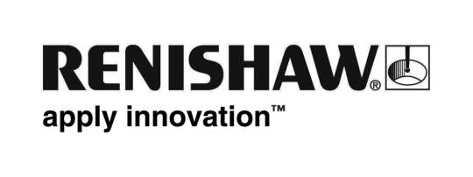
October 2018 Enquiries: Chris Pockett, Head of Communications (+44 1453 524133)

Renishaw hosts Secretary of State for Wales for visit focused on supporting engineering

Alun Cairns MP, Secretary of State for Wales, recently visited global engineering company Renishaw’s site in Miskin, near Cardiff to discuss the future of engineering in Wales. Cairns met with representatives from Renishaw to discuss how businesses and the Welsh Government can work together to create an engineering workforce with the skills necessary to support the industry and boost the Welsh economy.

Cairns toured the facility to see the company’s specialist work in precision manufacturing, additive manufacturing and healthcare. He also toured the facility’s Healthcare Centre of Excellence, where the company additively manufactures (‘3D prints’) metal dental structures and implants for facial reconstructive surgery. The additive manufacturing systems used to produce these medical parts are assembled at the Miskin site.

The Secretary of State for Wales also had the opportunity to speak to Stephen Pickles, Process Development Technician and Apprentice of the Year at the Apprenticeship Awards Cymru in 2017. The former Renishaw apprentice told him how the company is using education outreach programmes to encourage young students to consider a career in engineering.

“The UK Government is working closely with businesses to ensure we have the engineering skills in place to secure a strong economy and a workforce for the future,” explained Cairns. “Companies like Renishaw are helping us to create prosperous communities in Wales by training hundreds of people in the area to help them realise their potential and contribute to the industry and the economy.”

“We have invested over £45 million in our Miskin facility as a commitment to developing our presence in Wales,” explained William Lee, Chief Executive of Renishaw. “During his visit, the Secretary of State had the opportunity to see how our investment benefits people across South Wales. It includes our extensive education outreach programme centred around our Fabrication Development Centre (FDC), a dedicated facility to support primary and secondary schools in the area. This is to ensure that young people have the necessary skills to help develop our business over the coming years.”

Cairns’ visit to Renishaw comes during the UK Government’s Year of Engineering campaign, which celebrates the industry and aims to boost engineering across the UK with funding and education.

For more information about Renishaw’s education outreach programme in Miskin, visit www.renishaw.com/educationoutreach.

Ends 371 words
Notes to editors
UK-based Renishaw is a world leading engineering technologies company, supplying products used for applications as diverse as jet engine and wind turbine manufacture, through to dentistry and brain surgery. It has over 4,500 employees located in the 36 countries where it has wholly owned subsidiary operations.

For the year ended June 2018 Renishaw recorded sales of £611.5 million of which 95% was due to exports. The company’s largest markets are China, the USA, Germany and Japan.

Throughout its history Renishaw has made a significant commitment to research and development, with historically between 13 and 18% of annual sales invested in R&D and engineering. The majority of this R&D and manufacturing of the company’s products is carried out in the UK.

The Company’s success has been recognised with numerous international awards, including eighteen Queen’s Awards recognising achievements in technology, export and innovation.

Further information at http://www.renishaw.com/

