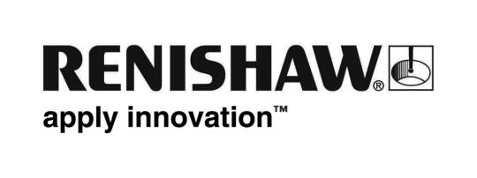
September 2018 Enquiries: Chris Pockett, Head of Communications (+44 1453 524133)

Renishaw inspires at South West Big Bang Fair

Engineering technologies company, Renishaw recently attended the South West Big Bang Fair at the University of the West of England (UWE) in Bristol to help inspire a new generation of engineers. At the show, Renishaw offered careers advice and ran engineering activities for visitors to its stand.

Engineering UK research found that only 36 per cent of eleven to fourteen-year olds know what steps to take after finishing secondary school to become an engineer. To change this, Engineering UK set up Big Bang Fairs across the country to give students access to careers advice from local engineering companies.

Some of Renishaw’s science, technology, engineering and maths (STEM) ambassadors — a group of apprentices, graduates and engineers that volunteer their time to promote STEM subjects and careers — attended the fair to help students and parents understand more about the sector. Visitors had the opportunity to speak to these ambassadors about the different paths into engineering and offered practical careers advice based on their own experiences.

Renishaw also ran two hands-on activities during the day to show visitors the creative side of engineering. Students could ride an ‘energy bike’, where they had to keep pedalling to turn on lights and see how much energy they could produce. Students also had the opportunity to make magnetic top chasers, which demonstrated some of the skills that are required in engineering. Renishaw also had some of its products on the stand to give students an idea of the range of careers that require engineering skills, including 3D printed objects produced by its additive manufacturing machines, neurological products and measurement tools.

“Businesses need to do more to get students excited about STEM in schools,” explained Rebecca Bound, Education Outreach Officer at Renishaw. “Every Big Bang Fair is specific to its location. Renishaw takes part as it is an opportunity to showcase the engineering specialities and opportunities that we offer in the South West. Exhibiting at the fair helps us to give visitors a taste of what a STEM career can offer as well as showcasing the career opportunities specifically at Renishaw, such as our apprenticeships and graduate schemes.”

The Big Bang Fair is a programme of UK-wide events that aims to get students excited about STEM subjects. The fairs have hands-on exhibits, interactive workshops and a wide range of careers advice from local and national employers. In 2017/18, more than 170,000 students and over 900 employers visited regional and local fairs to increase uptake of STEM subjects at a higher level. To find a local Big Bang Fair visit https://nearme.thebigbangfair.co.uk/visit-a-near-me-fair/

For more information about Renishaw’s STEM ambassadors and the company’s commitment to education outreach, visit http://www.renishaw.com/en/education-outreach--34713

Ends 440 words
Notes to editors
UK-based Renishaw is a world leading engineering technologies company, supplying products used for applications as diverse as jet engine and wind turbine manufacture, through to dentistry and brain surgery. It has over 4,500 employees located in the 35 countries where it has wholly owned subsidiary operations.

For the year ended June 2018 Renishaw recorded sales of £611.5 million of which 95% was due to exports. The company’s largest markets are China, the USA, Germany and Japan.

Throughout its history Renishaw has made a significant commitment to research and development, with historically between 13 and 18% of annual sales invested in R&D and engineering. The majority of this R&D and manufacturing of the company’s products is carried out in the UK.

The Company’s success has been recognised with numerous international awards, including eighteen Queen’s Awards recognising achievements in technology, export and innovation.

Further information at www.renishaw.com

