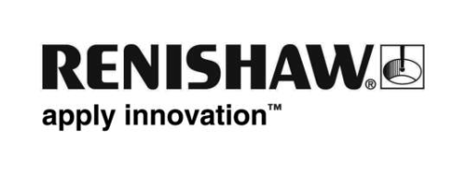
November 2012 – for immediate release Further information: Chris Pockett, +44 1453 524133

Renishaw opens high-tech manufacturing plant to Welsh students

Renishaw, the global engineering technologies company, has opened the doors of its new manufacturing facility in Miskin, South Wales, to 700 students from across South Wales at two special “Education Days” held during October and November.

Students and pupils from 18 schools, 6 universities and 2 colleges visited the new Renishaw plant, which was formally opened by Welsh First Minister, Carwyn Jones on 10 October 2012. The visits aimed to inspire a new generation of engineers and gave young people the opportunity to visit one of the most high-tech manufacturing plants in the UK, where they were given a tour of the machine shop and a temporary exhibition stand, which featured the entire range of Renishaw products including an additive manufacturing machine and surgical robot.

The well documented engineering skills shortage in the UK has meant that Renishaw has struggled to fill vacancies for high skilled engineering positions. Through joint initiatives with education establishments, Renishaw is working hard to promote engineering as a career, and to remove the negative associations and beliefs regarding the manufacturing and engineering sectors.

Julie Collins, Education Liaison Executive at Renishaw, explains: “Both days have given us a really good start into introducing Renishaw to the education organisations in Wales which we can now build on to develop good long term relationships and a sustainable pipeline of future engineers.”

Feedback from students and teachers was very positive: “The students were really interested – they were buzzing when they left”; “The tour was very insightful and helpful. It allowed me to gain more experience looking at the actual machines and having them explained by an expert rather than just looking at a picture and having our teacher explain”.

- ENDS -

