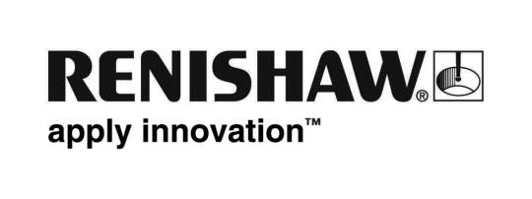
June 2019 Enquiries: Chris Pockett, Head of Communications (+44 1453 524133)

Renishaw races ahead in International Women in Engineering Day celebrations
Global engineering technologies company Renishaw is the official sponsor of the 2019 Castle Combe heat of the national Greenpower electric car racing competition. This year the event falls on International Women in Engineering Day on the 23rd of June.

During the event at the Castle Combe Circuit in Wiltshire, Renishaw will be running a stand to encourage competitors to consider a career in Engineering and will highlight that diversity in the engineering industry is fundamental to its long-term success and sustainability.

On the day, competitors in the F24 (ages 11-16) and F24+ (ages 16-25) category will race electric cars that they have built, completing as many laps of the track as possible within an hour. The aim is to use the twelve-volt batteries and standard motors in the car as efficiently as possible so that the cars travel the furthest distance in the allocated time.

As sponsors of the event, Renishaw will also run hands-on engineering activities to encourage young people to get excited about science, technology, engineering and maths (STEM) and consider engineering as a career. Racers will be able to use Renishaw’s energy bike to see how much energy they can generate and try to light up LED and incandescent lightbulbs. Renishaw is also running a homopolar motor activity where visitors can create paperclip spinners.

“Engineering is often perceived as a male-only industry,” explained Rebecca Bound, Education Outreach Officer at Renishaw. “As a sponsor of a competition on International Women in Engineering Day, we want to demonstrate to the female competitors that the skills that they have developed in building their cars, can be utilised for an exciting and rewarding career in engineering.”

Renishaw runs an extensive education outreach programme for school students across Gloucestershire, Bristol and South Wales to encourage more young people to consider engineering as a career. As a part of the programme Renishaw has a team of over 150 STEM ambassadors, who run events and workshops across the area. Approximately 33 per cent of Renishaw’s STEM ambassadors are female and are great role models for encouraging girls into STEM.

Greenpower Education Trust is a UK based charity that runs competitions across the UK, USA, Poland and China to spark enthusiasm in STEM subjects through the excitement of motorsport. For more information about Renishaw’s education outreach programme, visit http://www.renishaw.com/education-outreach.

Ends 335 words
Notes to editors
UK-based Renishaw is a world leading engineering technologies company, supplying products used for applications as diverse as jet engine and wind turbine manufacture, through to dentistry and brain surgery. It has over 4,500 employees located in the 36 countries where it has wholly owned subsidiary operations.

For the year ended June 2018 Renishaw recorded sales of £611.5 million of which 95% was due to exports. The company’s largest markets are China, the USA, Germany and Japan.

Throughout its history Renishaw has made a significant commitment to research and development, with historically between 13 and 18% of annual sales invested in R&D and engineering. The majority of this R&D and manufacturing of the company’s products is carried out in the UK.

The Company’s success has been recognised with numerous international awards, including eighteen Queen’s Awards recognising achievements in technology, export and innovation.

Further information at http://www.renishaw.com/

