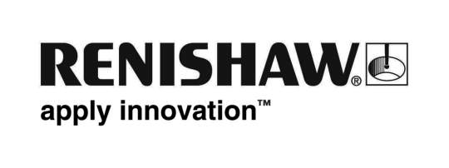
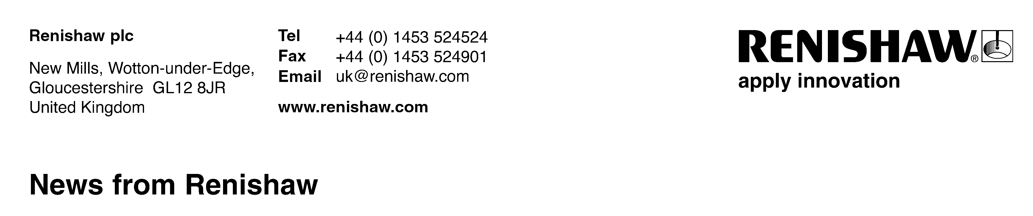
May 2019 Enquiries: Chris Pockett, Head of Communications (+44 1453 524133)

Renishaw shares insights at new industrial AM event
To encourage the widespread use of serialised additive manufacturing (AM) in a broad range of applications, Marc Saunders, Director of AM Applications at engineering technologies company, Renishaw, is giving a talk at Additive Next 2019. From the 4th to the 5th of June 2019, the brand-new industrial AM event, organised by Sandvik and Siemens, will be held at Högbo Brukshotell, Sandviken, Sweden. On Tuesday June 4th, from 15:00 to 15:30, Saunders will share his insight on how multi-laser AM can boost productivity without compromising on the quality of the final product.

Saunders’ talk will enlighten visitors on how production orientated laser powder bed fusion (LPBF) machines increasingly feature multiple lasers to boost build rates, raise productivity and lower part costs. It will explain how multiple lasers in close proximity present a new set of challenges and it will reveal how these should be dealt with.

Renishaw has gained vast experience in multi-laser AM since the launch of its pioneering RenAM 500Q metal AM system, which includes four 500W lasers in the most commonly used platform size. These lasers can operate independently on separate parts, as well as cooperate on single large components. The RenAM 500Q allows manufacturers to speed up production by up to four times, without compromising on the overall quality of their product.

“At the moment, AM only makes a small percentage of the total global manufacturing market,” explained Saunders. “Once the adoption of multi-laser technology becomes widespread, it will transform the industry, appeal to new markets and become more popular. The increase in productivity and decrease in cost-per-part that multi-laser AM technology enables are unrivalled.”

Saunders has over 25 years' experience in high tech manufacturing and precision engineering. As the Director of AM Applications at Renishaw, he runs a global network of Solutions Centres for metal additive manufacturing and is responsible for developing process techniques for new materials.

The Additive Next 2019 - Industrial AM for Real event will gather AM experts from industry, research and education. The two-day event will address some of the key trends in the field, as well as outline the main challenges faced when moving from research to serial production.

For more information on Renishaw’s additive manufacturing products and services visit www.renishaw.com/additive.

Ends 379 words
Notes to editors
UK-based Renishaw is a world leading engineering technologies company, supplying products used for applications as diverse as jet engine and wind turbine manufacture, through to dentistry and brain surgery. It has over 4,500 employees located in the 36 countries where it has wholly owned subsidiary operations.

For the year ended June 2018 Renishaw recorded sales of £611.5 million of which 95% was due to exports. The company’s largest markets are China, the USA, Germany and Japan.

Throughout its history Renishaw has made a significant commitment to research and development, with historically between 13 and 18% of annual sales invested in R&D and engineering. The majority of this R&D and manufacturing of the company’s products is carried out in the UK.

The Company’s success has been recognised with numerous international awards, including eighteen Queen’s Awards recognising achievements in technology, export and innovation.

Further information at www.renishaw.com

