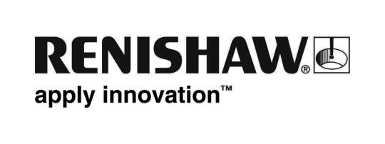
February 2018 Enquiries: Chris Pockett, Head of Communications (+44 1453 524133)

Renishaw shortlisted for Company of the Year at PLC Awards

Gloucestershire based global engineering technologies company, Renishaw, has been shortlisted for Company of the Year at the PLC Awards, 2017. The annual awards are sponsored by PwC and supported by the Financial Times and the London Stock Exchange. The ceremony will take place on March 15th, 2018, at the Grosvenor House Hotel in London. This marks the first time Renishaw has been shortlisted in the category, which is awarded to a company that has demonstrated long-term success.

Following nominations from a voting panel made up of representatives from London’s financial community, Renishaw was selected as one of six shortlisted companies for the prestigious award. This is the first time the company has been shortlisted in this category, though it has been recognised for its technology previously in the PLC Awards. In March 2011, Renishaw was awarded the Best Technology Award and the following year, it was nominated again in the same category.

The Company of the Year award is given to a business that has clearly demonstrated that success is not just a short-term phenomenon. The category, which is sponsored by Liberum, assesses companies improved, sustainable profitability and long-term vision.

“Renishaw has had an extremely strong year, growing in turnover, profits and people,” said Chris Pockett, Head of Communications at Renishaw. “Since 2009, the company has grown from 1,850 staff to 4,500 employees globally and, this year, we are taking on a record number of apprentices.

“Renishaw has experienced excellent international success, which is reflected in our growing network of subsidiaries,” continued Pockett. “2017 saw Renishaw establish a new Turkish subsidiary, relocate to offices triple the size in Spain and start work on a new building in Mexico. We also formally opened a new 133,000 square feet headquarters in the US.”

The company continues to invest in research and development (R&D), devoting around 15 per cent of annual sales to R&D. The company has a long-term focus on product development as well as on skills, offering an expansive education outreach programme to inspire the next generation of engineers, as well as an award-winning apprenticeship scheme.

For more information on Renishaw visit, www.renishaw.com.

Ends 352 words
Notes to editors
UK-based Renishaw is a world leading engineering technologies company, supplying products used for applications as diverse as jet engine and wind turbine manufacture, through to dentistry and brain surgery. It has over 4,000 employees located in the 35 countries where it has wholly owned subsidiary operations.

For the year ended June 2017 Renishaw recorded sales of £536.8 million of which 95% was due to exports. The company’s largest markets are China, the USA, Japan and Germany.

Throughout its history Renishaw has made a significant commitment to research and development, with historically between 14 and 18% of annual sales invested in R&D and engineering. The majority of this R&D and manufacturing of the company’s products is carried out in the UK.

The Company’s success has been recognised with numerous international awards, including eighteen Queen’s Awards recognising achievements in technology, export and innovation.

Further information at www.renishaw.com

