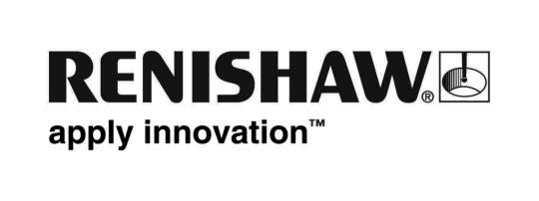
January 2018 Enquiries: Chris Pockett, Head of Communications (+44 1453 524133)

Renishaw strengthens international business ties with India
At the twelfth annual meeting of the UK-India Joint Economic and Trade Committee (JETCO), Rhydian Pountney, Managing Director of Renishaw UK Sales Limited, chaired the Technological Collaboration, Advanced Manufacturing and Engineering Working Group. Held at One Great George Street in Westminster, UK, the meeting discussed how the UK and India can further their economic partnership and strengthen the relationship between the two countries.

The annual meeting was chaired by Shri Suresh Prabhu, Honourable Minister of Commerce and Industry, and Rt. Honourable Dr. Liam Fox MP, Secretary of State for International Trade. The meeting aimed to promote ongoing trade between the two countries to achieve mutual prosperity and enhance competitiveness. Alongside the ministerial meetings, the organisation runs Working Groups, chaired by business representatives from the UK and India.

The Technological Collaboration, Advanced Manufacturing and Engineering Working Group was chaired by Pountney and Dr Gopichand Katragadda, Group CTO at Tata Sons. It was well attended by representatives from the Department of International Trade (DIT) and Confederation of Indian Industry, as well as participants from businesses such as Rolls Royce, BAE Systems and TWI. Attendees discussed how the two countries can collaborate as part of technical research and development.

The group’s discussion will input into a Joint Trade Review, which analyses trade barriers in
the advanced manufacturing industrial sectors and gives advice on how to overcome them. The review will assess topics including how the UK’s Catapult Centre model could be used in India and how to develop skills in India.

“Renishaw is a world-leading manufacturing company, with expertise in digital manufacturing and additive manufacturing,” explained Pountney. “95 per cent of Renishaw’s recorded sales in 2017 came from export, which puts us in a strong position to discuss and debate international trade.

“JETCO’s annual meetings and Working Groups provide a key opportunity for India and the UK to work together, supported at Government level,” continued Pountney. “Renishaw’s expertise in the UK and India as an advanced manufacturer puts us in a great position to share our views on and insight into research and development.”

Pountney is an experienced export professional, with first-hand knowledge of managing a network of overseas operations. He has also sat on the UK Trade and Investment (UKTI) Advanced Engineering Sector Advisory Board and has been the UK chair for the UK-India JETCO Working Group since 2013. As well as this, Pountney established a B2B Working Group in India alongside the opening of Renishaw’s Additive Manufacturing Solutions Centre in Pune.

Ends 410 words
Notes to editors
UK-based Renishaw is a world leading engineering technologies company, supplying products used for applications as diverse as jet engine and wind turbine manufacture, through to dentistry and brain surgery. It has over 4,000 employees located in the 35 countries where it has wholly owned subsidiary operations.

For the year ended June 2017 Renishaw recorded sales of £536.8 million of which 95% was due to exports. The company’s largest markets are China, the USA, Japan and Germany.

Throughout its history Renishaw has made a significant commitment to research and development, with historically between 14 and 18% of annual sales invested in R&D and engineering. The majority of this R&D and manufacturing of the company’s products is carried out in the UK.

The Company’s success has been recognised with numerous international awards, including eighteen Queen’s Awards recognising achievements in technology, export and innovation.

Further information at www.renishaw.com

