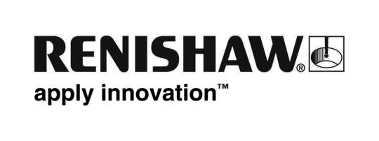
May 2018 Enquiries: Chris Pockett, Head of Communications (+44 1453 524133)

Renishaw supports winning students at South Wales Big Bang Fair
Global engineering company Renishaw attended the South Wales Big Bang Fair, held recently at Parc Y Scarlets, Llanelli. At the show, Renishaw promoted engineering careers to sixth form students from its dedicated stand. Since October 2017, the company has supported teams from Howell’s School and Monmouth School with their competition entries. Howell’s School won the overall competition and will represent the region at the UK national competition next year.

The Big Bang Fair is the largest annual science, technology, education and maths (STEM) fair in South Wales. As part of the event, schools take part in the Engineering Education Scheme Wales (EESW) Sixth Form Project. This involves developing the solution to a real industrial problem, set by local companies over a period of six months. Renishaw set its teams the challenge of designing a device to accurately measure a part for one of the company’s position encoders.

In 2018, a total of 84 teams entered the competition, with 75 exhibiting on the day. The team from Monmouth School won the Best Application of Engineering and Technology Award and was nominated for the Best Working Model or Prototype. Team two from Howell’s School was nominated for Most Effective Presentation of the Solution, Best Application of Science and Best Working Model or Prototype.

Along with two other schools from the South Wales area, Howell’s School team one was named overall winners, as well as winners for the Best Working Model or Prototype. They will now represent South Wales at the National Big Bang Fair at the NEC in Birmingham in March 2019.

“Renishaw held regular meetings with the sixth form teams to develop and build ideas,” explained Simon Biggs, Education Outreach Officer at Renishaw. “The students were able to work alongside Renishaw’s engineers and apprentices to develop their skills and understanding. The measurement nature of the project meant the students were developing a solution that could be used within Renishaw.”

“The engineers from Renishaw were impressive role models for the students, relating well to the students and offering valuable guidance and support,” added Dr Andrew Ford, Head of Physics at Howell’s School. “The students have learnt about design, engineering and project management, leaving enthused and excited by their experience and excited for the next step.”

Renishaw also had a stand at the event staffed by its Education Outreach team, who were able to answer any questions the students had on engineering, graduate placements and apprenticeships. For more information, visit www.renishaw.com/outreach.

Ends 403 words
Notes to editors
UK-based Renishaw is a world leading engineering technologies company, supplying products used for applications as diverse as jet engine and wind turbine manufacture, through to dentistry and brain surgery. It has over 4,000 employees located in the 35 countries where it has wholly owned subsidiary operations.

For the year ended June 2017 Renishaw recorded sales of £536.8 million of which 95% was due to exports. The company’s largest markets are China, the USA, Japan and Germany.

Throughout its history Renishaw has made a significant commitment to research and development, with historically between 14 and 18% of annual sales invested in R&D and engineering. The majority of this R&D and manufacturing of the company’s products is carried out in the UK.

The Company’s success has been recognised with numerous international awards, including eighteen Queen’s Awards recognising achievements in technology, export and innovation.

Further information at www.renishaw.com

