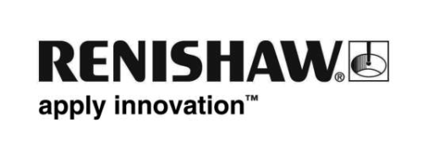
August 2013 – for immediate release Further information: Chris Pockett, +44 1453 524133

Renishaw to exhibit a range of advanced engineering products at Northern Manufacturing 2013

Renishaw, the global engineering technologies company, will be exhibiting a range of its precision metrology and advanced engineering products at Northern Manufacturing 2013 at Event City, in Manchester, UK from 2 – 3 October 2013.

On show at stand B46 will be Renishaw's Equator™, a lightweight, fast and highly repeatable inspection system that operators can use with ‘push-button' simplicity. Equator's innovative flexible gauging technology is based on the comparison of production parts to a reference master part, which can greatly increase throughput and reduce scrap rates at a fraction of the cost of an equivalent custom gauging system.

Also exhibited will be Renishaw’s pioneering laser melting technology. The AM250 utilises an additive manufacturing process capable of producing fully dense metal parts direct from 3D CAD, using a high-powered fibre laser. Parts are built from a range of fine metal powders that are fully melted in a tightly controlled atmosphere, in layer thicknesses ranging from 20 to 100 microns.

Visitors to Northern Manufacturing will see that in addition to the conveniences of wireless operation, the QC20-W telescoping ballbar is the first calibration tool to allow testing in 3 orthogonal planes through a single reference point. A single, simple hardware set up means quicker testing and the ability to produce a representative volumetric measurement of positioning accuracy.

Continuing the theme of machine tool calibration, Renishaw will also be showing the new XR20-W rotary axis calibration system and XL-80 laser interferometer. The XR20-W system works with the market leading XL-80 to allow the measurement of rotary axis positional accuracy to within 1 arc second. Totally wireless operation and modular mounting systems ensure suitability for a wide range of machines.
-ENDS-

