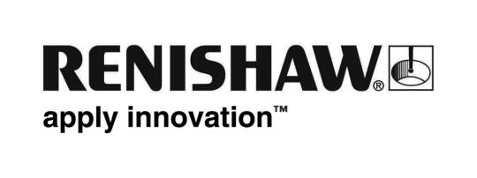
April 2018 Enquiries: Chris Pockett, Head of Communications (+44 1453 524133)

Spotlight on productive additive manufacturing at MACH 2018

At MACH 2018, held at the NEC in Birmingham, UK, from April 9th-13th, global engineering company, Renishaw, showcased the benefits of its additive manufacturing products range to manufacturers. The company exhibited its additive manufacturing products and software in the 3D Printing Zone as well as a stand dedicated to its extensive range of metrology products. During MACH, Renishaw was visited by Sir Ben Ainslie, Team Principle and Skipper for the Land Rover BAR America’s Cup team, who thanked Renishaw for its significant contribution to the team.

On its additive manufacturing stand, in the 3D printing and additive manufacturing zone, Renishaw exhibited its work as part of Land Rover BAR’s Technical Innovation Group (TIG) for the 2017 America’s Cup. Renishaw contributed encoder technology and an additively manufactured manifold to the technologically advanced foiling race boat.

“Renishaw was lucky enough to be visited by Sir Ben Ainslie, who officially opened the show, on the first day of MACH,” explained Stephen Crownshaw, Business Manager at Renishaw’s Additive Manufacturing Products Division. “He was impressed with the technology we provided for the America’s Cup, as well as Renishaw’s measurement equipment, including the Equator gauge.

“Sir Ben Ainslie launched the show with a powerful opening speech about fostering engineering in the UK, encouraging young people to get involved in engineering and the TIG. Renishaw is proud to work with Land Rover BAR, as it shares these values.”

Across MACH, there was a focus on connectivity, robotics and automation and productivity. Renishaw tapped into this trend by highlighting its latest additive manufacturing system, the RenAM 500Q, which can increase productivity up to four times in the most commonly used platform size and boasts automated powder and waste handling systems. Renishaw also showed videos of InfiniAM Spectral, a software product which allows real-time analysis of build data.

During the show, Renishaw was visited by BBC Breakfast and BBC Midlands Today, who both broadcast interviews from the company’s stand. For more information on Renishaw visit www.renishaw.com.

Ends 335 words
Notes to editors
UK-based Renishaw is a world leading engineering technologies company, supplying products used for applications as diverse as jet engine and wind turbine manufacture, through to dentistry and brain surgery. It has over 4,000 employees located in the 35 countries where it has wholly owned subsidiary operations.

For the year ended June 2017 Renishaw recorded sales of £536.8 million of which 95% was due to exports. The company’s largest markets are China, the USA, Japan and Germany.

Throughout its history Renishaw has made a significant commitment to research and development, with historically between 14 and 18% of annual sales invested in R&D and engineering. The majority of this R&D and manufacturing of the company’s products is carried out in the UK.

The Company’s success has been recognised with numerous international awards, including eighteen Queen’s Awards recognising achievements in technology, export and innovation.

Further information at www.renishaw.com

