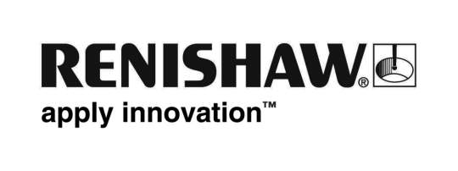
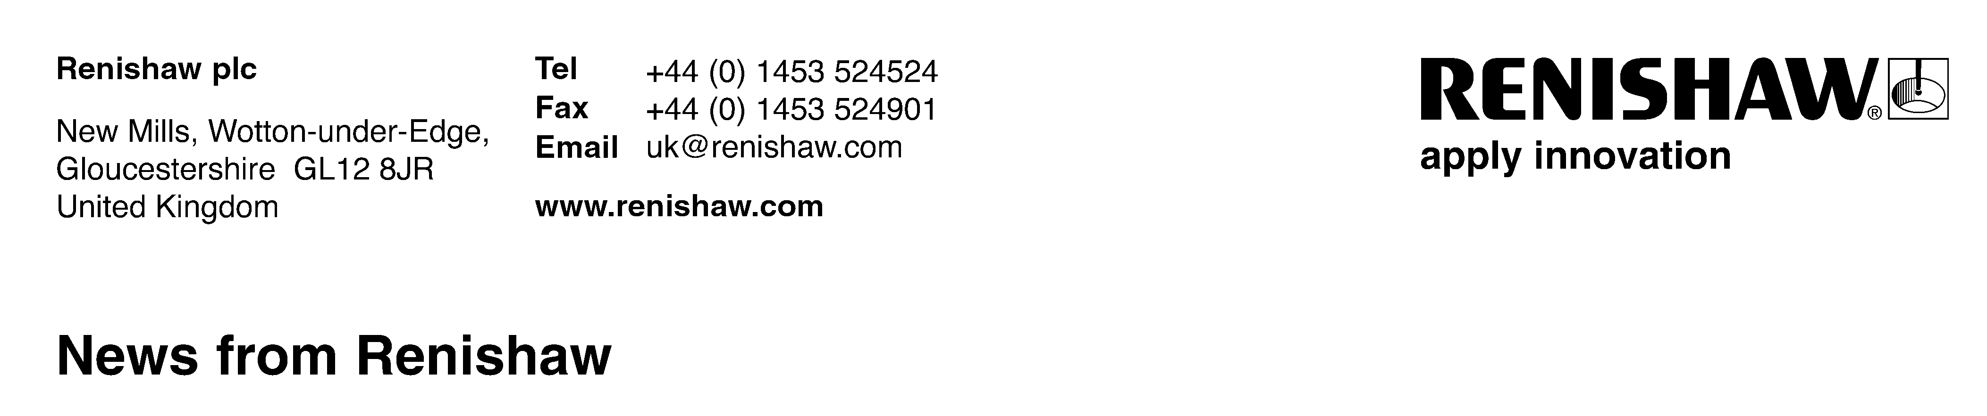
RENISHAW PLC AND BIOMET 3i – NOW PROVIDING THE LATEST DIGITAL DENTISTRY SOLUTIONS TO LABORATORIES, DENTAL IMPLANT PROFESSIONALS AND PATIENTS
Gloucestershire, UK – (July 9, 2010) – Renishaw plc, a leading manufacturer of in-lab dental scanning systems announces a collaboration with Biomet 3i, an industry leader in implant dentistry and a subsidiary of Biomet, Inc., to offer comprehensive digital solutions to dental professionals and patients worldwide.
Building on its portfolio of Patient Specific CAD/CAM Restorative Products, Biomet 3i is expanding the boundaries of a traditional “dental implant” company by providing a series of innovative digital solutions from which laboratories, clinicians and patients can benefit. For Renishaw, which supplies precision engineering products to sectors as diverse as aerospace and neurosurgery, it represents the opportunity to spread its expertise in dental manufacturing to a wider global audience.
These digital solutions offered by Biomet 3i and Renishaw include:
- 3i incise Copings and Frameworks;
- Renishaw contact scanners;
- 3i incise CAD software; and
- Renishaw in-lab milling machines
Using the Renishaw scanner and 3i incise CAD software, laboratories can obtain broader access to a wide range of dental milling options, including the ability to scan precision copy milled bar patterns.* Laboratories utilizing the ProceraForte® Scanner can also benefit from all of these options by using the 3i incise CAD software.
Clinicians can now offer patients 3i incise Copings and Frameworks in Zirconia and Cobalt Chrome** and precision copy milled bars.* These options are patient specific and designed to result in beautifully crafted new smiles.
“We feel that this partnership will provide our mutual dental customers with unsurpassed access to the latest in digital dentistry technology” said Maggie Anderson, president of Biomet 3i. Sir David McMurtry, Chairman and Chief Executive of Renishaw plc agreed, adding “Renishaw is thrilled to be combining its innovative engineering and CAD/CAM capabilities with Biomet 3i’s renowned clinical excellence and international sales and marketing expertise.” ENDS
*510(k) pending for precision copy milled bars scanned on Renishaw Systems, not available for sale in the United States
**Cobalt Chrome only available in Europe
Nobel Biocare Services AG is the owner of ProceraForte mark.
About Renishaw plc
Renishaw is well established as the world’s leading provider of in-lab scanning systems, having produced systems both under the Renishaw brand and under the brand of a number of other key dental companies, for over 10 years. As a leading engineering technology company, Renishaw has extensive research and development programs , enabling users to benefit from over 35 years of cutting-edge innovation in industrial measurement and CAD/CAM, bringing a new understanding and precision to the manufacture of metal-free dental frameworks. Renishaw is based in Gloucestershire, England, with operations internationally. For more information about Renishaw plc, please visit www.renishaw.com.

About Biomet 3i
Biomet 3i, a division of Biomet, Inc., is a leading manufacturer of dental implants, abutments and related products. Since its inception in 1987, Biomet 3i has been on the forefront in developing, manufacturing and distributing oral reconstructive products, including dental implant components and bone and tissue regenerative materials. The company also provides educational programs and seminars for dental professionals around the world. Biomet 3i is based in Palm Beach Gardens, Florida, with operations throughout North America, Latin America, Europe and Asia-Pacific. For more information about Biomet 3i, please visit www.biomet3i.com or contact the company at (800) 342-5454; outside the US dial +1 (561) 776-6700.

About Biomet
Biomet, Inc. and its subsidiaries design, manufacture and market products used primarily by musculoskeletal medical specialists in both surgical and non‐surgical therapy. Biomet’s product portfolio encompasses reconstructive products, including orthopedic joint replacement devices, bone cements and accessories, autologous therapies and dental reconstructive implants; fixation products, including electrical bone growth stimulators, internal and external orthopedic fixation devices, craniomaxillofacial implants and bone substitute materials; spinal products, including spinal stimulation devices, spinal hardware and orthobiologics; and other products, such as arthroscopy products and softgoods and bracing products. Headquartered in Warsaw, Indiana, Biomet and its subsidiaries currently distribute products in approximately 90 countries. For more information about Biomet, please visit www.biomet.com or contact the company at (800) 348-9500. Outside the U.S., dial +1 (574) 267-6639.

Contacts

Biomet 3i:
Sharon Bournes, Director of Advertising, Promotions and Communications
Biomet 3i
+1 561-776-7625
Sharon.Bournes@Biomet.com

Biomet, Inc.:
Bill Kolter, Corporate Vice-President, Public Affairs
Biomet, Inc.
+1 574-372-1535
Bill.Kolter@Biomet.com

Renishaw, plc:
Chris Pockett
Group Marketing Services Manager
Renishaw plc
T: +44 1453 524133
Chris.Pockett@Renishaw.com

